MAJOR ASSIGNMENT

B VENKATA JAGADISH

Creation of all four tables and its structure

Milestone 1a:

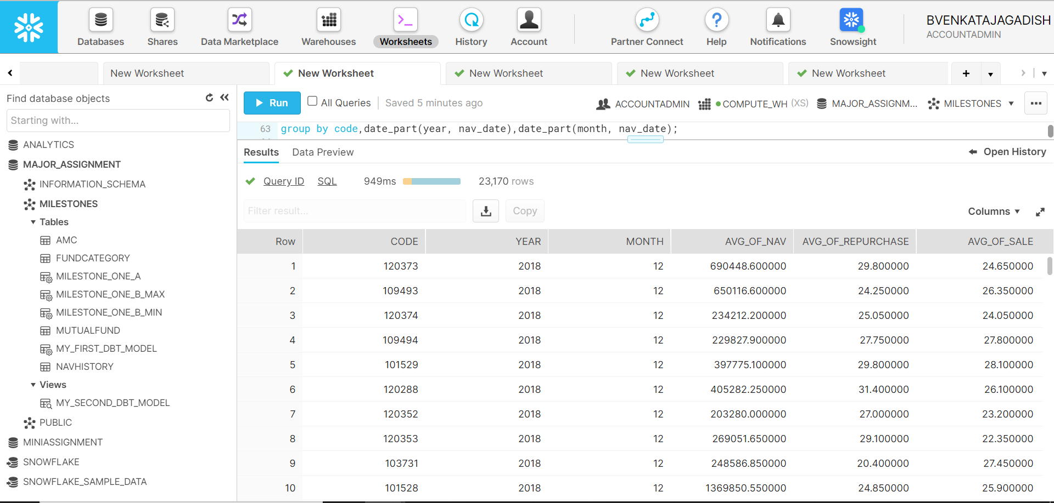

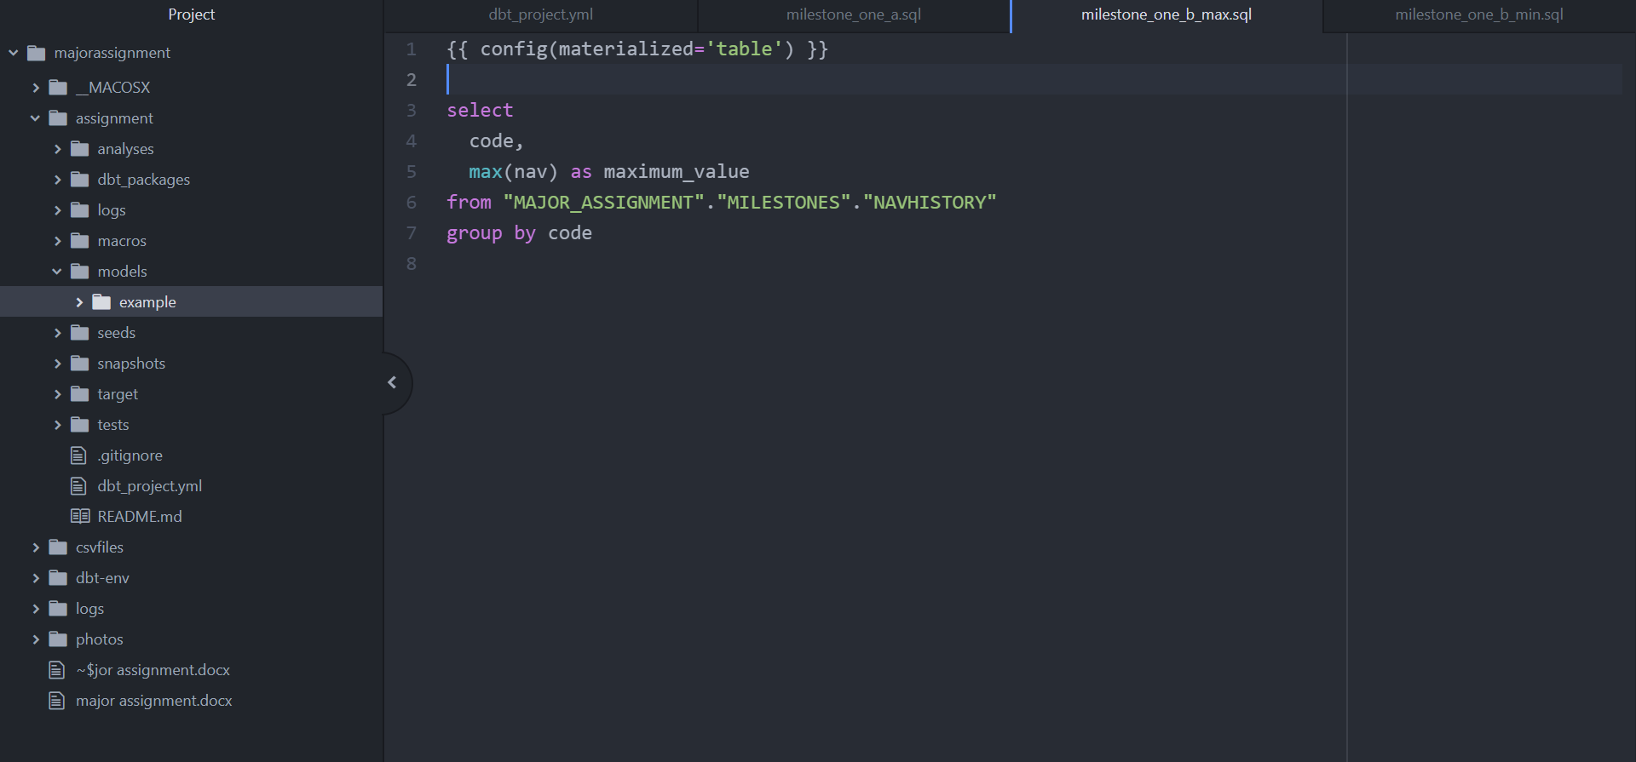Milestone 1b

